Pets

You need to add 20 things to this document. (Make sure to number them just as I did in the example.) It may be helpful to copy and paste this list and then fill it in as you go along. All image names must start with your location, e.g yellowstone_sunset.jpg unless you are using a link from the internet.

1. Basil
2. 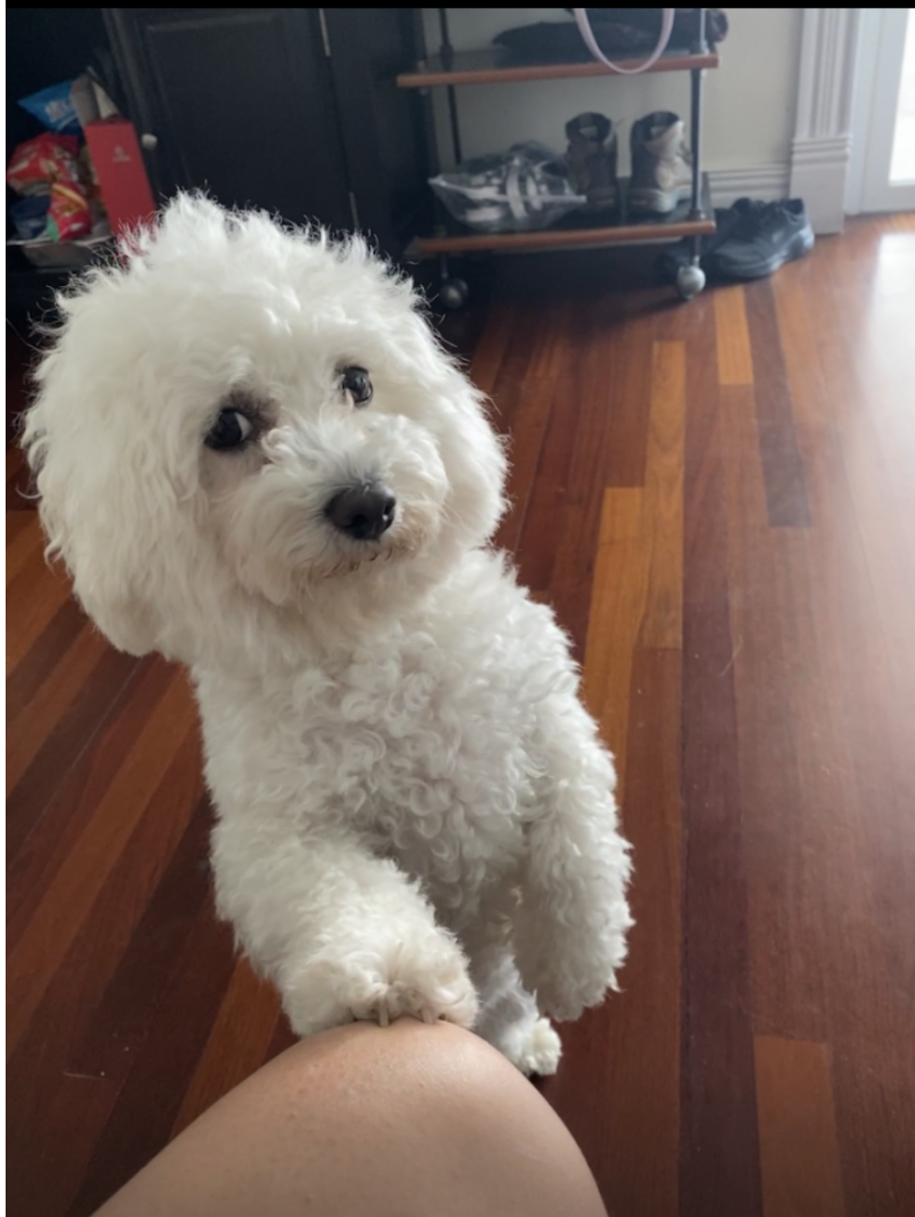
3. gurl_who_u_looking_at.png
4. Fluffy white dog with paw on knee, begging for attention and giving you the side eye
5. Basil, otherwise known as Slaysil, is a very energetic white, slightly crusty and trusty, dog (bichon) . She gets princess treatment in her household, but also out in public. As a consequence, she is very clingy and loves to lick, especially in the face.
6. She endeavors in multiple hobbies and activities, which include flying, licking, standing on two legs, ringing bells, and jumping through hula hoops.

For the next four pictures you can just put the names of the files, you don't have to include the files in this drive, but you do need to add them to the proper Google Drive.

1. **Photo Gallery**
2. naruto_basil.png
3. White bichon in a naruto robe (Akatsuki)
4. balloosil.png
5. Balloon attached to white bichon
6. pet_me.png
7. White bichon leaning against leg
8. superbasil_HOP.png
9. White bichon floating in air while running
10. **Likes**
11. Empty water bottles
12. Socks
13. Cats
14. Bianca and Alina